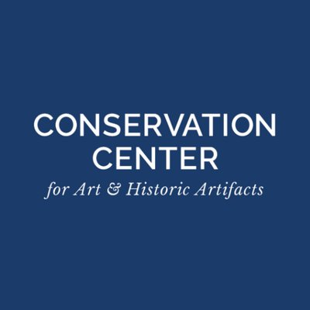
Volunteer Here! Returning to Collections Care series
Welcome Back! Speedy Tips for Volunteers Returning to Collections Work
September 21, 2021
Conservation Center for Art & Historic Artifacts, https://ccaha.org/
- COVID-19 Resources for Cultural Institutions,
https://ccaha.org/covid-19-resources-cultural-institutions
- Education Programming, including Guides & Fact Sheets,
https://ccaha.org/education
- YouTube channel,
https://www.youtube.com/channel/UCdv19rjrblgl_cn4WocvHIQ

American Association for Museum Volunteers, https://aamv.wildapricot.org/
- AAMV March 2021 Survey Results, https://aamv.wildapricot.org/resources/Documents/Winter%2021%20Survey%20Results.pdf
- AAMV July 2020 Survey Results,
https://aamv.wildapricot.org/resources/Documents/COVID%20Survey%20Summary.pdf
- “COVID-19 and Your Volunteer Program,” https://aamv.wildapricot.org/COVID19
- “Designing a Museum Volunteer Program,” podcast series, https://aamv.wildapricot.org/page-18162
- “Sample Corona Virus for Volunteers Document,” https://docs.google.com/document/d/1mGahzL3CmVDu3oMcqpxaM6byshJ3bmLzdWvp-umizjc/edit
“Collections Management Policy,” American Alliance of Museums, https://www.aam-us.org/programs/ethics-standards-and-professional-practices/collections-management-policy/
Connecting to Collections Care website, https://www.connectingtocollections.org/
- “Collections Management for Smaller Cultural Institutions, https://www.connectingtocollections.org/course-collections-management/

“COVID-19 Resources & Information for the Museum Field,” American Alliance of Museums, https://www.aam-us.org/programs/about-museums/covid-19-resources-information-for-the-museum-field/
“Designing a Museum Volunteer Program,” American Alliance of Museums, paid resource available at https://www.aam-us.org/programs/toolkits/designing-a-museum-volunteer-program/
“Do Volunteer Programs Need Reinventing for the Reopened Museum?,” American Alliance of Museums, August 5, 2020. https://www.aam-us.org/2020/08/05/do-volunteer-programs-need-reinventing-for-the-reopened-museum/
Federal Emergency Management Agency (FEMA) “Coronavirus (COVID-19) Pandemic: Safe Opening and Operation Work Eligible for Public Assistance Policy,” https://www.fema.gov/sites/default/files/documents/fema_covid-19-pandemic-safe-opening-operation-work-eligible-public-assistance-interim-policy_2_09082021.pdf
- FEMA regions: https://www.fema.gov/about/organization/regions
Library of Congress, “The Impact of Hand Sanitizers on Collection Materials,” https://www.loc.gov/preservation/scientists/projects/sanitize.html
- See also, Ryan, Cindy Connelly, “Assessing the Impact of Sanitizing Products on Collection Items,” June 14, 2021, https://blogs.loc.gov/preservation/2021/06/assessing-the-impact-of-sanitizing-products-on-collection-items/
Merritt, Elizabeth, “COVID-19 and Museum Volunteers,” Center for the Future of Museums Blog, May 28, 2020. https://www.aam-us.org/2020/05/28/covid-19-and-museum-volunteers/
Points of Light, “Considerations for In-Person Corporate Volunteering During COVID-19: Guidance for Companies,” March 31, 2020. https://www.pointsoflight.org/wp-content/uploads/2020/04/Considerations-for-In-Person-Corporate-Volunteering-During-COVID-19-3-31-20.pdf
REopening Archives, Libraries, and Museums (REALM) Project, https://www.oclc.org/realm/home.html
“Volunteer Engagement Amid the COVID-19 Pandemic,” Sterling Volunteers, April 30, 2020. https://www.sterlingvolunteers.com/blog/2020/04/volunteer-engagement-and-covid-19/
*This page includes a link to the 2020 webinar, “Volunteer Engagement Amid the Coronavirus Pandemic: A Virtual Convening.” The webinar is free, but a brief registration is required.
“Volunteers in the Time of COVID,” webinar by the Ohio Museums Association, September 28, 2020. https://www.youtube.com/watch?v=XBHWtsqldY8

